**LAB MANUAL**

**NAME: MAHBOOB ALI**

**ROLL NO: BIT-24S-027**

**Lab no 08**

* **Task 1: Function-based Calculator (+ and - only)**

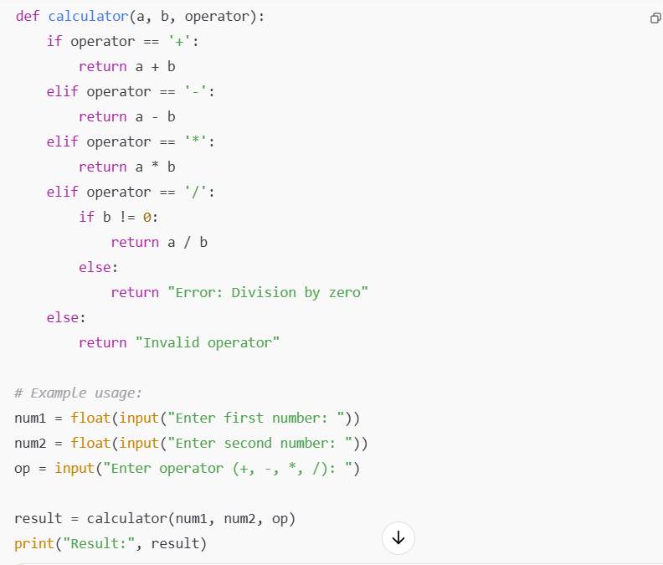

**Output:**

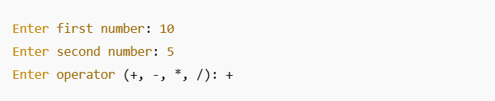

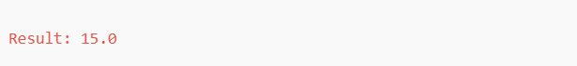

* **Task 2: Function to print star shapes (triangle or rectangle).**

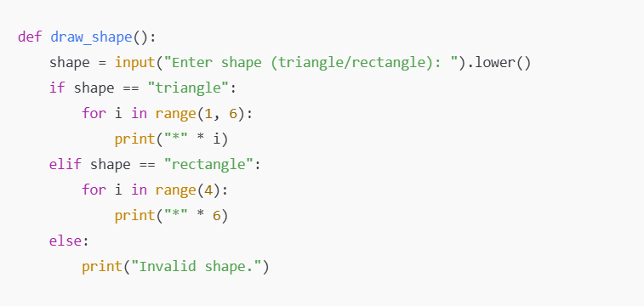

**Output:**

